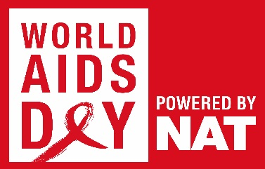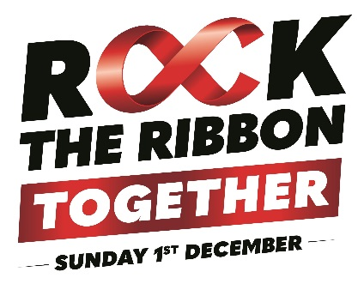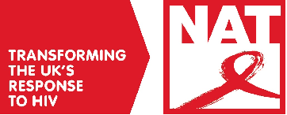
QUIZ ROUND: World AIDS Day 2019
- A) What does HIV stand for stand for?

B) What does AIDS stand for?

- Picture round: Which of the following images is the HIV virus?
A  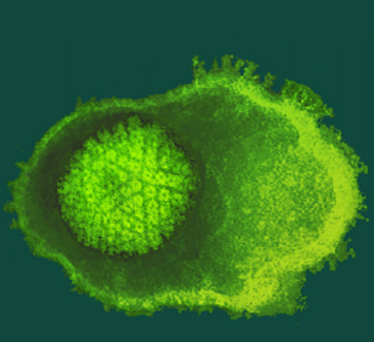 | B  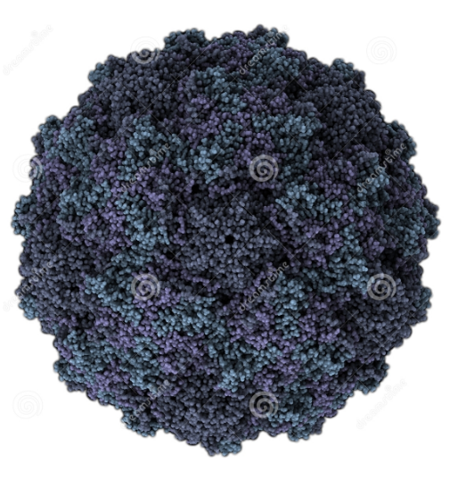
C  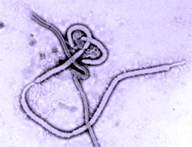 | D  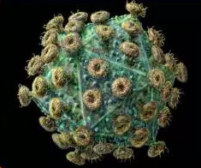

- How many people do Public Health England estimate are living with HIV in the UK? The figure includes people who have not been diagnosed.

a) 47, 300
b) 79, 800
c) 101, 600

- What proportion of these people do not know they have HIV?

a) 1 in 57
b) 1 in 29
c) 1 in 12

- What proportion of people diagnosed with HIV in 2017 were 25-49?

a) 12%
b) 23%
c) 42%
d) 68%

- What proportion of people living with HIV in the UK acquired their HIV through sharing needles, syringes or other injecting equipment?

- 2%
- 11%
- 23%
- 40%

- True or false: You can get HIV from a mosquito bite

- HIV can be transmitted by two of the following routes. Listen to them and circle Yes if you think it can be transmitted this way and no if you think it can’t:
Half a point for every correct answer
a) Sharing needles or syringes
b) Kissing someone
c) Sex without a condom with someone who has HIV but has an undetectable viral load
d) Spitting

- True or false: Pre-exposure prophylaxis, or PrEP, can prevent HIV transmission even when a condom isn’t used.

- Which was the first UK country to make PrEP available on the NHS?

- People living with HIV who are on effective treatment can’t pass the virus on, even if they have condomless sex. This is because the virus is lowered to what we call an ‘undetectable level’. The term we use for this is U = U. Undetectable = untransmissible.
What proportion of people on HIV treatment in the UK can’t pass the virus on?

a) 55%
b) 78%
c) 97%

- How often should you get tested for HIV if you are sexually active?

- At least once a year
- Every four weeks
- You don’t need to test for HIV unless you're at high-risk

- What are the benefits of HIV treatment?

- It prevents sickness and gives you a normal life expectancy
- It suppresses the virus so that you can’t pass it on
- Both of the above

- In which year did NAT (National AIDS Trust) win a legal challenge against NHS England as part of their battle to make the HIV prevention pill PrEP available on the NHS?

- True or false: There are some people who acquire HIV but manage to live well for decades without needing treatment.

- How long after exposure to HIV does it take for a HIV test detect the virus in your blood?

- According to a 2015 study of people living with HIV in the UK, what proportion had experienced people gossiping about their HIV positive status in the past year?

- 6%
- 10%
- 19%
- 33%

- In what year did a sitting member of UK Parliament first talk publicly about living with HIV?

- In 2009, which world leader removed a travel ban that prevented people living with HIV from entering the country they governed?

